CSA1203 ASSESSMENT

NAME: DHEVAGOPALAN B
REG NO: 192512134

Design and Analysis of an Energy-Efficient Pipelined Processor with Hierarchical Memory System for Smart Industrial Monitoring

System Architecture / Design
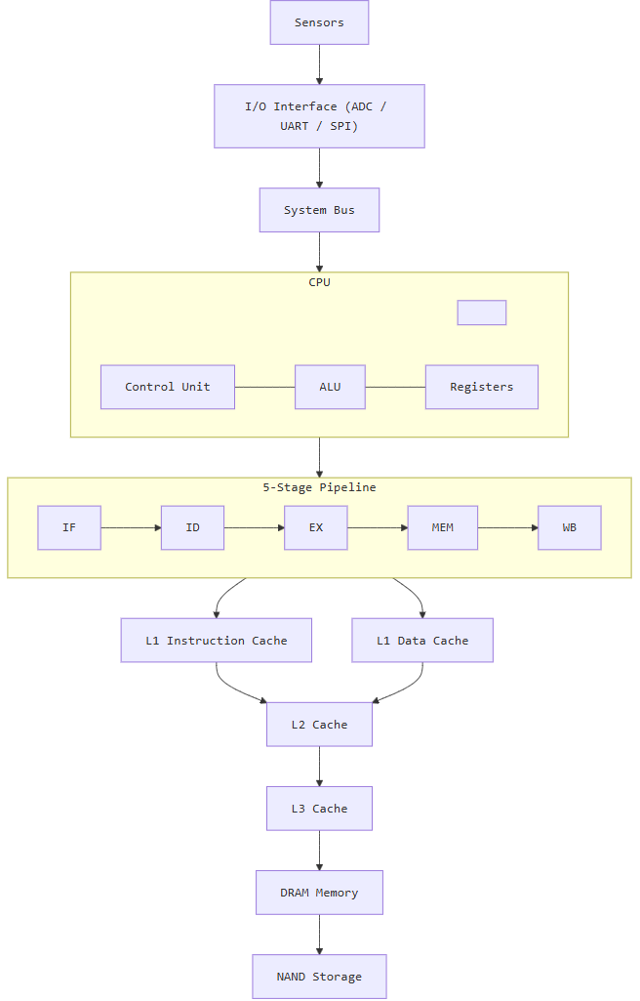

Calculations of
- CPI
- Clock cycles
- Execution time
- Speedup
- Cache hit/miss rate
- AMAT

1. CPI (Cycles Per Instruction)
Formula
$$CPI=\frac{Total Clock Cycles}{Total Instructions Executed}$$
Assume the optimized processor executes 1,000,000 instructions in 1,200,000 clock cycles.
$$CPI=\frac{1,200,000}{1,000,000} \\ \boxed{CPI=1.2}$$
Comparison
Processor Design | CPI
Non-Pipelined Processor | 4.5
Basic Pipelined Processor | 1.8
Optimized Pipelined Processor | 1.2
Result
The optimized pipelined processor has the lowest CPI of 1.2, indicating better instruction throughput.

2. Clock Cycle Time
Formula
$$Clock Cycle Time=\frac{1}{Clock Frequency}$$
Given:
$$Clock Frequency=1GHz \\ Clock Cycle Time=\frac{1}{1×{10}^{9}} \\ \boxed{Clock Cycle Time=1ns}$$
Result
Each processor clock cycle takes 1 nanosecond.

3. Total Clock Cycles
Formula
$$Total Clock Cycles=Instruction Count×CPI$$
Non-Pipelined Processor
$$=1,000,000×4.5 \\ \boxed{4,500,000 cycles}$$
Basic Pipeline
$$=1,000,000×1.8 \\ \boxed{1,800,000 cycles}$$
Optimized Pipeline
$$=1,000,000×1.2 \\ \boxed{1,200,000 cycles}$$
Comparison
Architecture | Instruction Count | CPI | Total Clock Cycles
Non-Pipelined | 1,000,000 | 4.5 | 4,500,000
Basic Pipeline | 1,000,000 | 1.8 | 1,800,000
Optimized Pipeline | 1,000,000 | 1.2 | 1,200,000

4. CPU Execution Time
Formula
$$CPU Execution Time=Total Clock Cycles×Clock Cycle Time$$
Alternatively:
$$CPU Execution Time=Instruction Count×CPI×Clock Cycle Time$$
A. Non-Pipelined Processor
$$=1,000,000×4.5×1ns \\ =4,500,000ns \\ \boxed{4.5ms}$$

B. Basic Pipelined Processor
$$=1,000,000×1.8×1ns \\ \boxed{1.8ms}$$

C. Optimized Pipelined Processor
$$=1,000,000×1.2×1ns \\ \boxed{1.2ms}$$
Final Comparison
Processor | Execution Time
Non-Pipelined | 4.5 ms
Basic Pipeline | 1.8 ms
Optimized Pipeline | 1.2 ms
Result
The optimized pipelined processor completes the same workload in the shortest time.

5. Speedup Calculation
Formula
$$Speedup=\frac{Execution Time of Old System}{Execution Time of New System}$$
Comparing non-pipelined and optimized pipelined processors:
$$Speedup=\frac{4.5}{1.2} \\ \boxed{Speedup=3.75}$$
Result
$$\boxed{The optimized pipeline is 3.75× faster}$$
than the non-pipelined processor.

6. Cache Hit Rate and Miss Rate
Given:
- Total Memory Accesses = 10,000
- Cache Hits = 9,500
- Cache Misses = 500
Cache Hit Rate
Formula
$$Hit Rate=\frac{Cache Hits}{Total Memory Accesses}×100 \\ =\frac{9500}{10000}×100 \\ \boxed{Hit Rate=95\%}$$

Cache Miss Rate
Formula
$$Miss Rate=\frac{Cache Misses}{Total Memory Accesses}×100 \\ =\frac{500}{10000}×100 \\ \boxed{Miss Rate=5\%}$$

Result
Parameter | Value
Total Accesses | 10,000
Cache Hits | 9,500
Cache Misses | 500
Hit Rate | 95%
Miss Rate | 5%
A high cache hit rate reduces expensive accesses to lower memory levels.

7. AMAT (Average Memory Access Time)
For a hierarchical memory system:
Formula
$$AMAT=L1 Hit Time+L1 Miss Rate×Miss Penalty$$
First calculate the L1 miss penalty.
L1 Miss Penalty
$$L1 Miss Penalty=L2 Access Time+L2 Miss Rate×Main Memory Access Time$$
Substitute:
$$=5+\left(0.10×100\right) \\ =5+10 \\ \boxed{L1 Miss Penalty=15ns}$$
Calculate AMAT
Given:
- L1 Hit Time = 1 ns
- L1 Miss Rate = 5% = 0.05
- L1 Miss Penalty = 15 ns
$$AMAT=1+\left(0.05×15\right) \\ =1+0.75$$

GRAPH COMPARISON

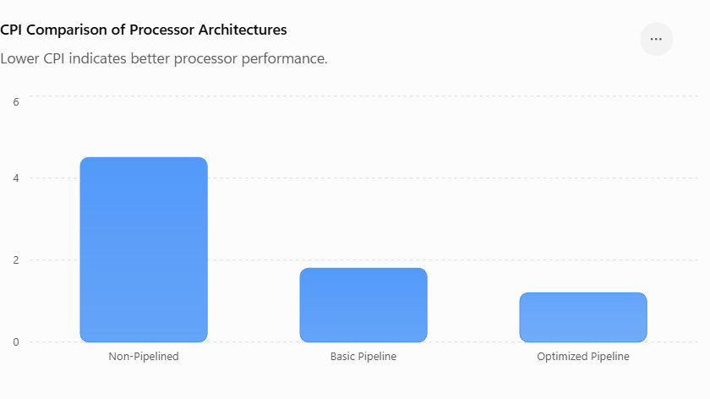
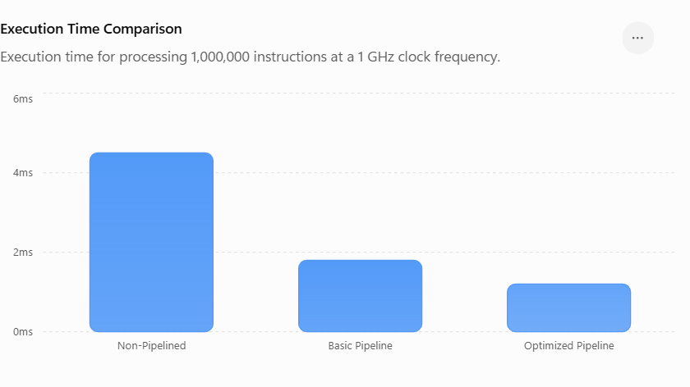

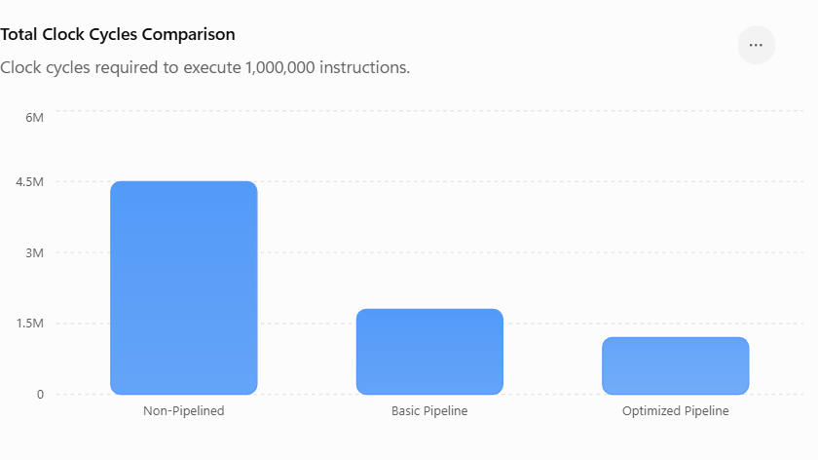
ROUGH GRAPH

CPI Comparison
CPI
4.5 ████████████████████ Non-Pipeline
1.8 ████████ Basic Pipeline
1.2 █████ Forwarding Pipeline

Graph 2: Execution Time Comparison
4.5ms ████████████████████ Non-Pipeline
1.8ms ████████ Basic Pipeline
1.2ms █████ Optimized Pipeline

